Students’ Questionnaire

Programme

* 1. Please choose the programme you are enrolled in:

Questionnaire

* 2. Programme in semester 2:

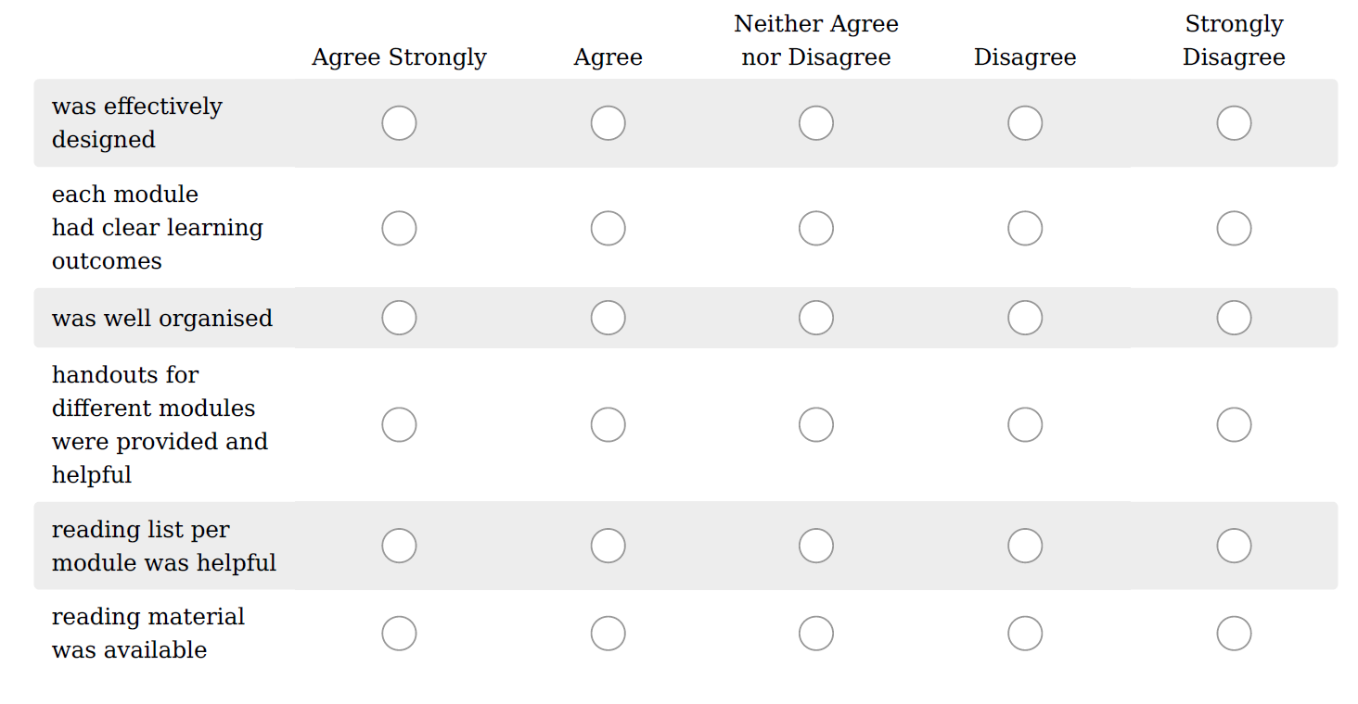

* 3. The teaching sessions:

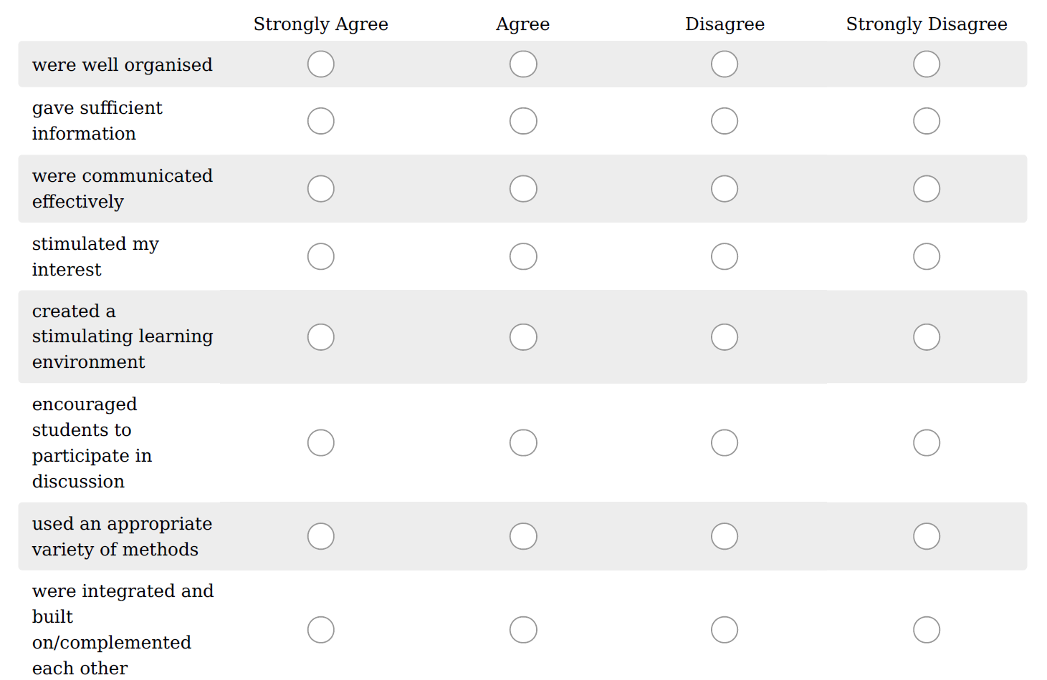

* 4. The Assessment:

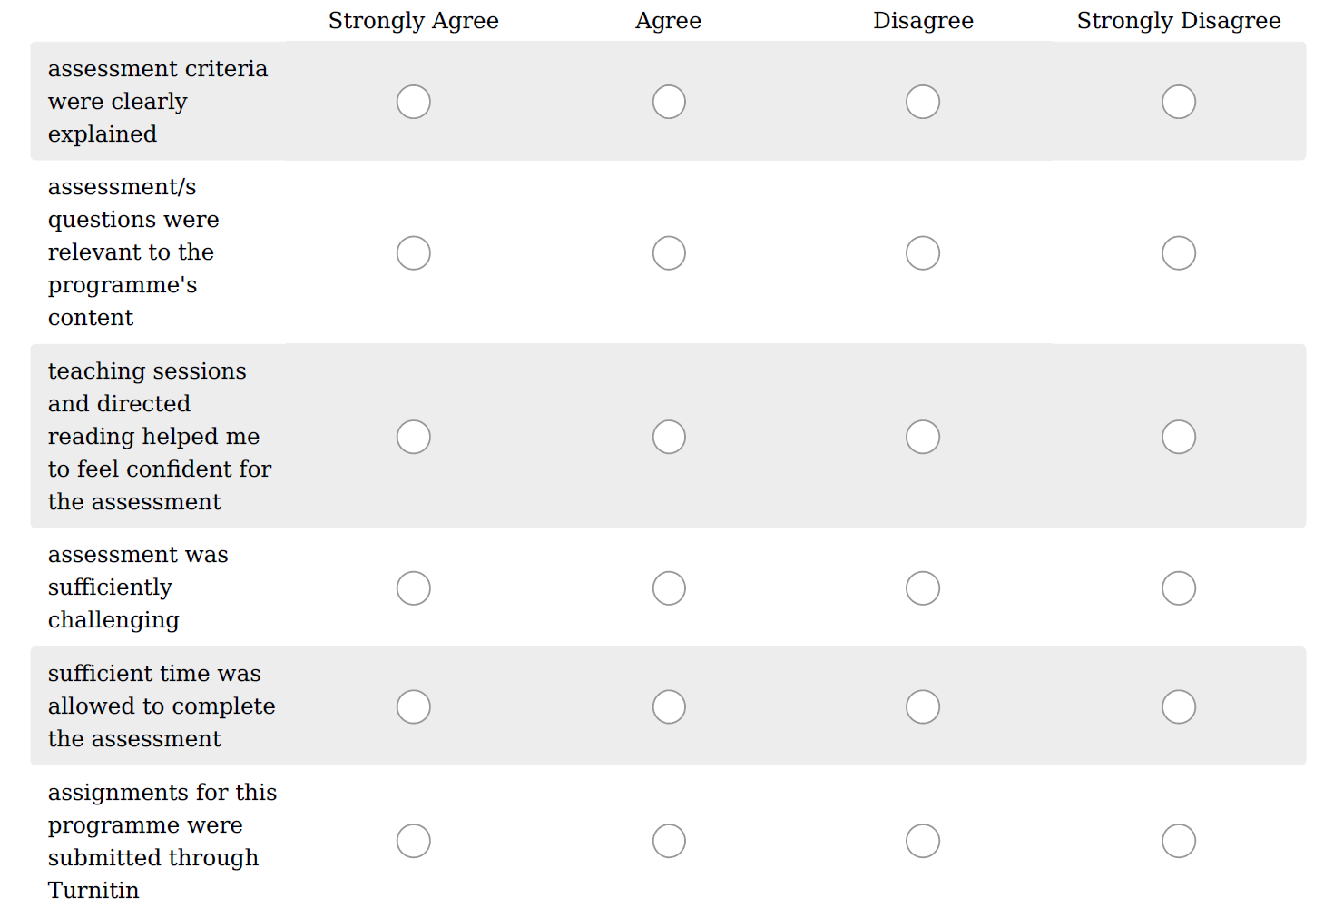
* 5. Programme Support:

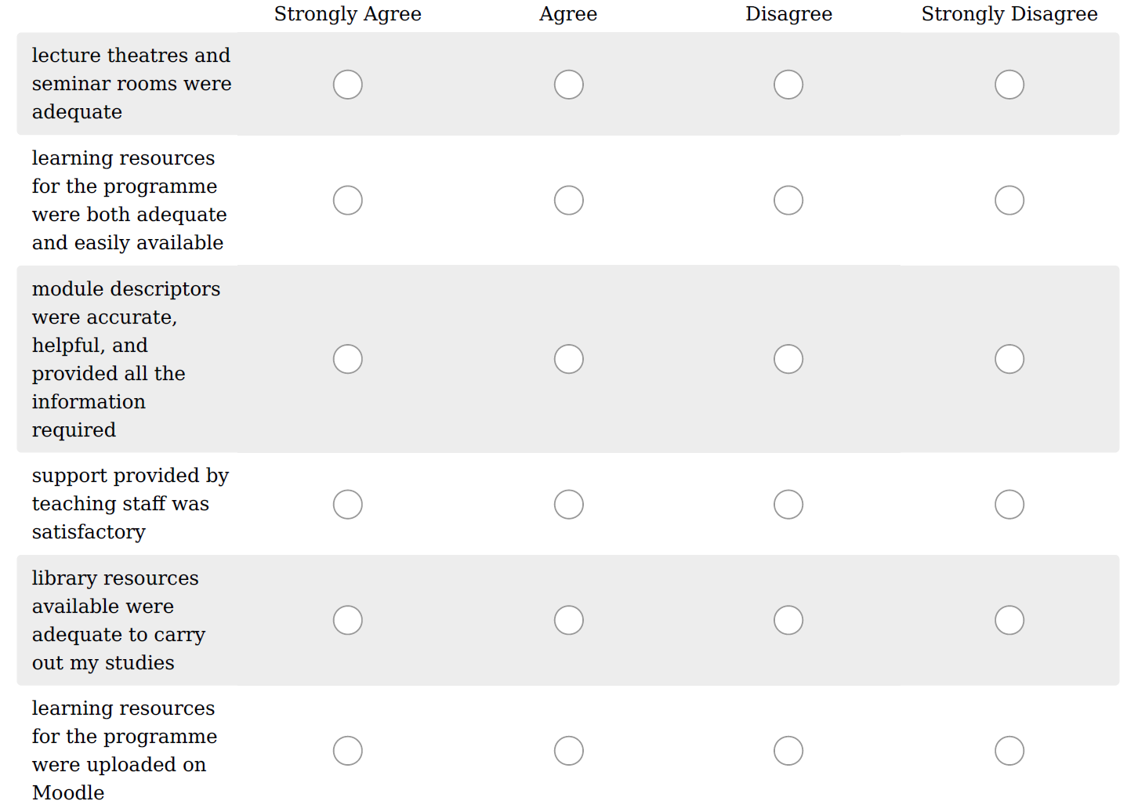

* 6. General:

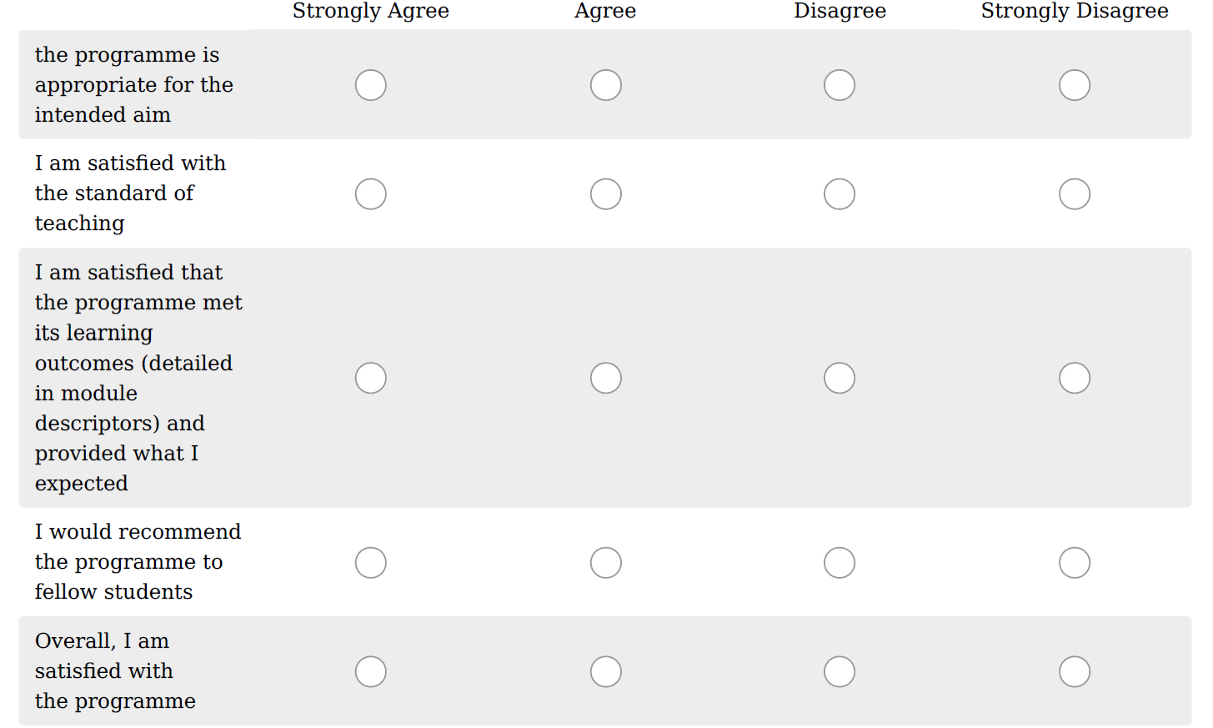
* 7. Please indicate your estimated attendance of this programme in semester 2:

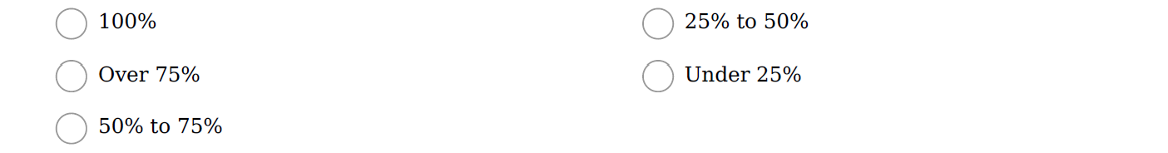

8. What went well in this programme?

9. What could have been improved on the programme and how?

Module Feedback
If you wish to provide feedback on specific module/s within your programme, kindly fill in this section.

10. Module title you wish to give feedback on

11. What is your feedback on the module/s

ITS Facilities and Resources

* 12. Which facilities did you make use of in semester 2

* 13. Are you satisfied with the resources offered at ITS?

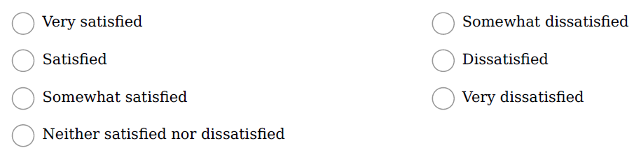

* 14. What facilities would you add within the ITS campus?

* 15. How safe do you feel in classrooms/ on campus?

16. Health and wellness support provided by ITS

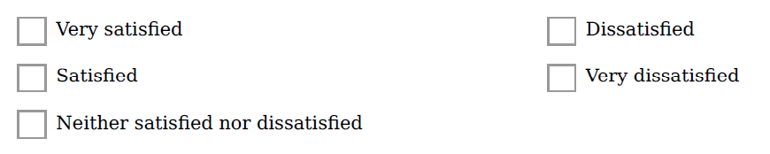

* 17. How helpful were administrative staff with your queries/ issues?

* 18. How satisfied are you with the cleanliness on campus?

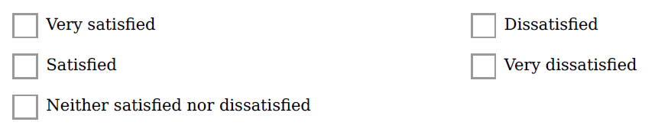

Overall Comments

* 19. How do you rate your overall experience at ITS till now?

20. Why?

21. Any other feedback?

